FACULTY PROFILE
Name | K.Venkata Narayana | 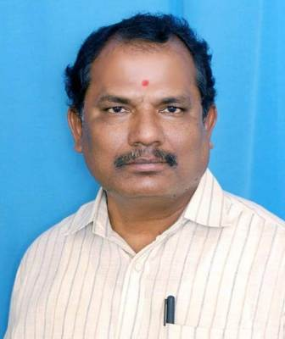
Department | Department of Economics
Designation | Contract faculty
Date of Appointment | 27-09-2004
Date of Birth | 02-05-1975
Contact Number | 9490594002
Email Id | Knarayana251975@gmail.com
Academic qualifications:
Qualification | Name of the University | Year of passing
Ph. D
M.SC/M.A/M.COM | M.A S.K.Universtity, Ananthapur | 1998
Others Qualifications (NET/SET etc.), if Any | SLET  APSET  B.Ed | 2000  2012  2002

Experience Details:
Designation | Name of the Institution, Place | From | To
Connect Faculty | GDC, Uravakonda | 2004 | 2006
Contract Faculty | KH GDC,Dharamavaram | 2006 | 2010
Contract faculty | GDC(M),Ananthapur | 2010 | 2012
Contract Faculty | PSC & KVSC GDC, Nandyala | 2012 | 2013
Contract Faculty | SVCR GDC, Palamaner | 2013 | 2023
Contract Faculty | SVAGDC(M), SRiKALAHASTHI | 2023 | Till now
Total Teaching Experience: P.G Classes: _____Years
U.G Classes: 20 Years.
Research Experience Including Years spent in M.Phil/Ph.D:
Fields of Specializations under the subject/Discipline:
a.
b.
List of research Publications/Books:
Title of the Paper | Journal | Year of Publishing | UGC CARE/SCI/SCOPUS etc.
List of Projects Completed:
Title of the Project | Sponsoring Agency | Major/Minor | Total Grant Received | Year of Completion
List of OC/RC/TOTs/FDP/MOOCS/ARPIT Attended:
Title of the course | Type of the Course (FDP/RC Etc.) | Duration | Organized by
Economics | FDP | 05 Days | CCE
Economics | FDP in LMS | 05 Day | CCE
Economics | PODCAST | 03 Days | CCE
TOT | TOT In Social work Methods | 05 Days | CCE
TOT | TOT In Financial Markets | 05 Days | CCE
TOT | TOT In Internship & LMS | 03 Days | CCE
TOT | Single major economics | 05 Days | CCE
SEEK & SEL | UNESCO MGIP | 01 Day | CCE
Co-Curricular, Extension and Professional Development Related Activities:
S.No | Name of the Activity | Details
1 | Student related Co- Curricular, extension and field-based activities (such as extension work through NSS/NCC and other channels, Cultural activities, subject related events and counseling.
2 | Contribution in corporate life and management of the department and participation in academic and administrative committees and responsibilities and Professional Development.
Awards/ Achievements: Please give details of any other credentials, significant contributions, awards received:
S.No | Name of the Award/Achievement | Date of Receiving
1

