**Extension Activities 2021-22**

**Awareness on National Deworming on 10.02.2022**

S.V.A. Government College (M), Srikalahasti, RRC & YRC committee collaborated with Department of Zoology and NCC organized a program “Awareness on National Deworming” on 10.02.2022. Principal Dr. Y. Nagaraja Naidu inaugurated the program and explained the importance of National Deworming Day. RRC & YRC committee work together with healthcare professionals to facilitate a safe and supervised deworming drive within the college premises. This awareness campaigns is used to educate students through posters about the importance of deworming. Vice-principal Dr.N.Murali, RRC & YRC coordinator Dr.M.Chandra Mouli, Department of Zoology Incharge Dr.K.Narasimha Varma, Smt..M.Thulasi WEC Convener and Dr.Naga Seshadri NCC Convener created health awareness and Albendazole tables have been distributed to all participants. Encourage NCC and NSS student volunteers to engage with the community, promoting health and hygiene while fostering a sense of responsibility and service. Albendazole tablets distributed to the students on the National deworming day in all classrooms of the college. The program was successfully completed.

**Smt..M.Thulasi distributed Albendazole tablets to the students in theclassromms**

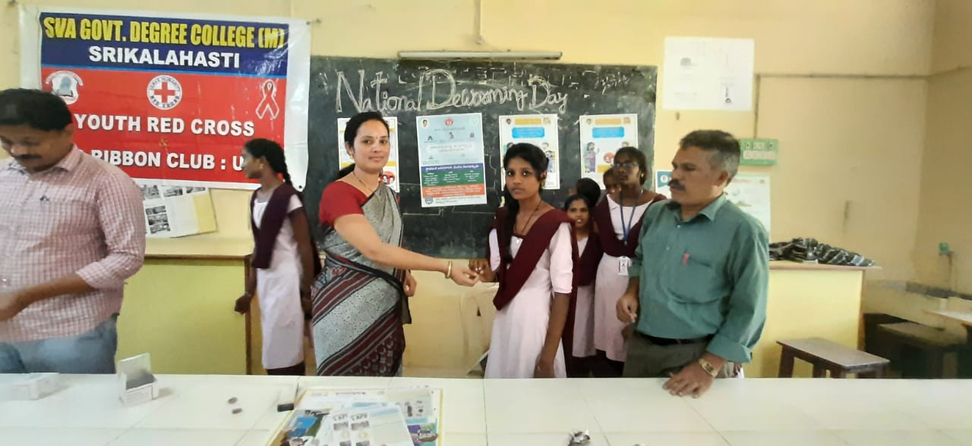

**Teaching staff distributed Albendazole tablets to the students in theclassromms**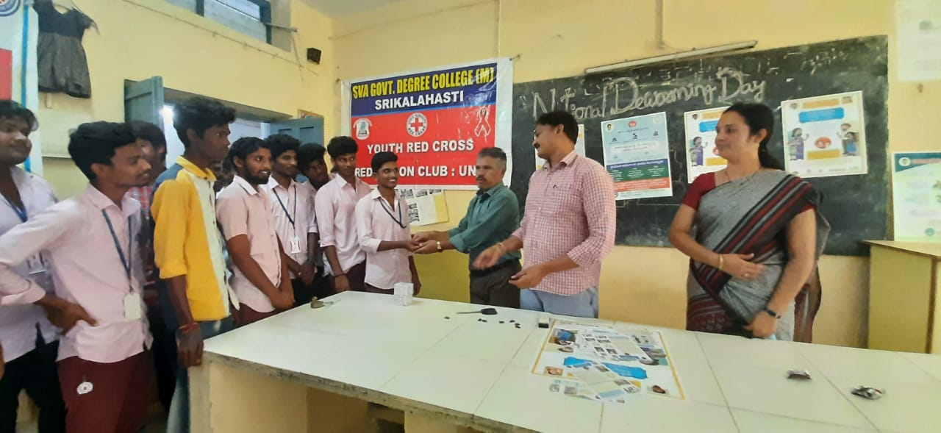

**Vice-principal Dr.N.Murali distributed Albendazole tablets to the students**

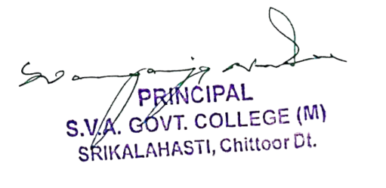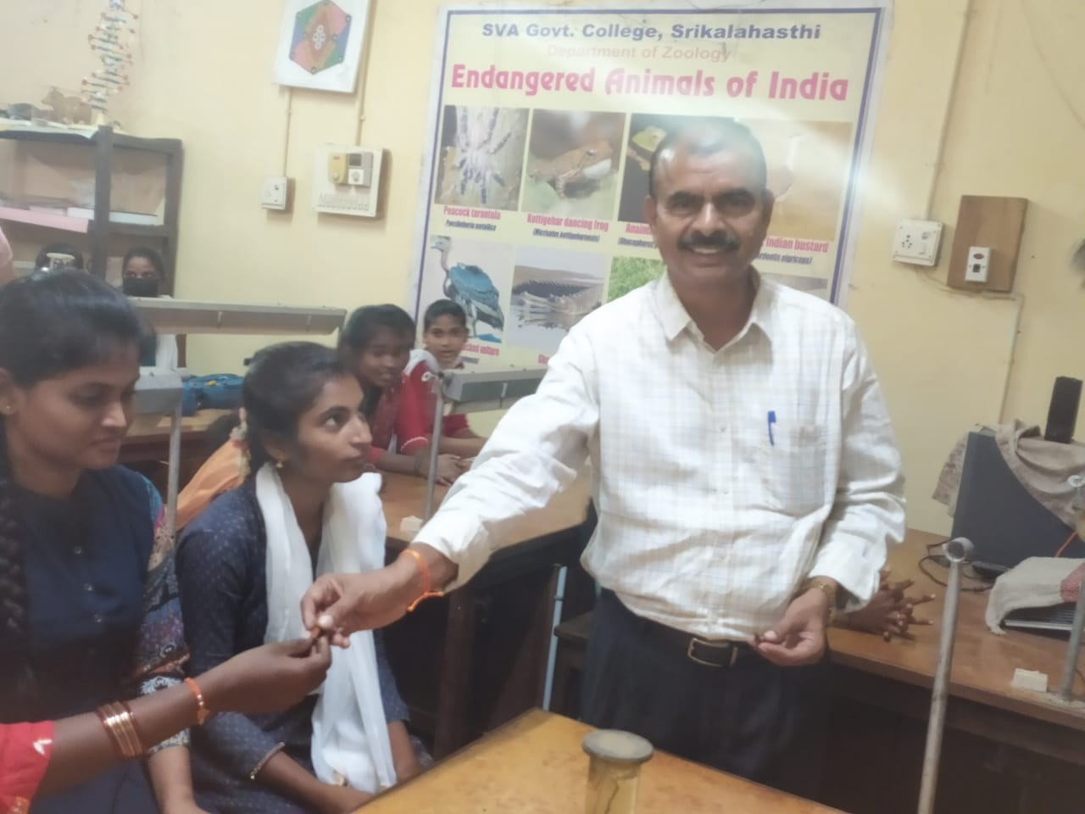

**Awareness Rally on Yoga and its Benefits on International Yoga Day**

**Date:** June 21, 2021

The SVA Government College Department of Physical Education and NSS successfully organized an awareness rally on Yoga and its benefits as a part of celebrations of International Yoga Day on June 21, 2021. The event was graced by the presence of the college principal, Dr. Y. Nagaraja Naidu, along with Physical Director Dr. Satyanarayana Reddy and NSS Program Officers B. Nagaiah and V. Babu Rao. A total of 24 staff members and 200 students actively participated in the celebration. The event commenced with a brief introduction to the significance of International Yoga Day and the benefits of yoga practice. Subsequently, a series of yoga asanas were performed by the participants under the guidance of trained yoga instructors. The session concluded with a relaxation exercise.

The college principal emphasized the importance of incorporating yoga into daily life for physical and mental well-being. He encouraged the students to make yoga a regular part of their routine. The NSS Program Officers also highlighted the role of yoga in promoting health and harmony. Overall, the Yoga Day celebration at SVA Government College was a resounding success. The event provided a platform for students and staff to learn about the benefits of yoga and to practice it together. The Yoga Day celebration was well-organized and received positive attention from the local community.

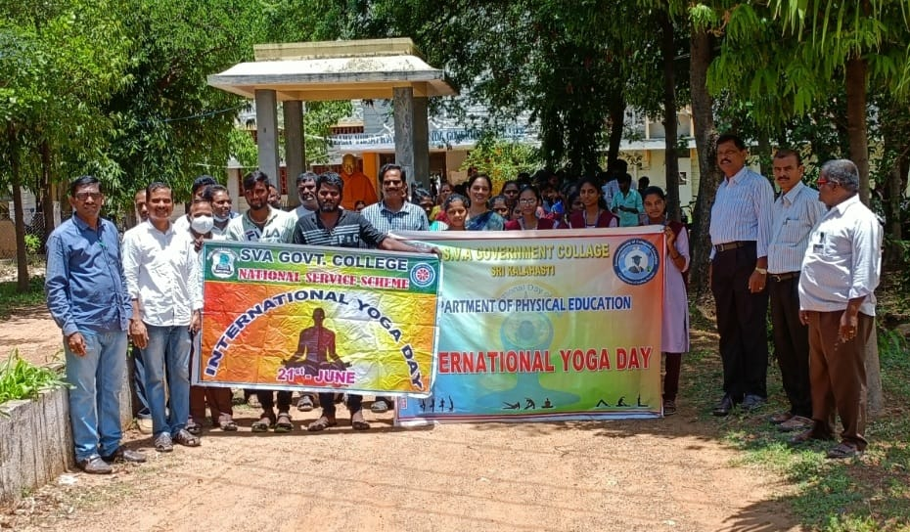

**Awareness programme on Girl Child Marriages**

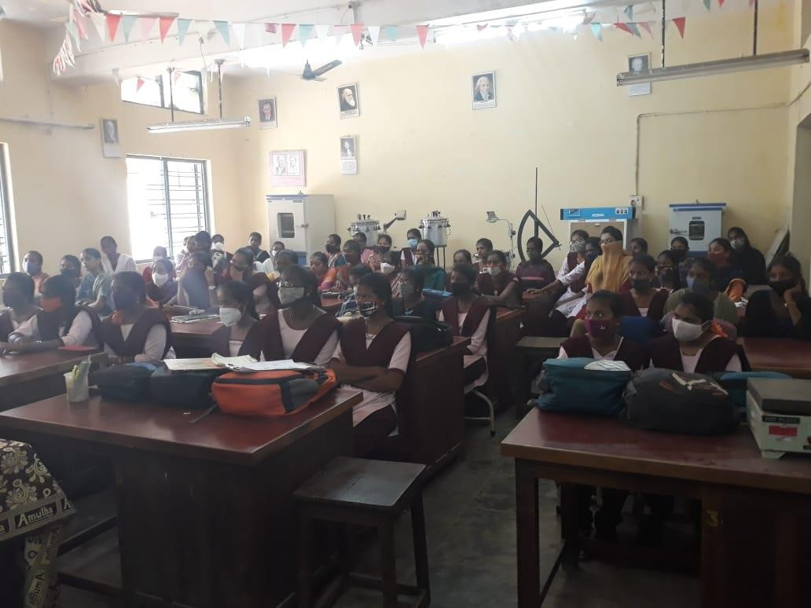The awareness program against Girl child marriages at SVA Government College (M), Srikalahasti, held on 17/02/2021. The objective of the program is to educate the community, especially parents and guardians, about the negative impacts of girl child marriages on the health, education and overall well-being of young girls. In this programme, Principal Dr.Y.Nagaraja Naidu created awareness on girl child marriages on the health, education and overall well-being of young girls. Dr.A. Indira Priyadarsini created awareness on girls by providing them with knowledge and resources to advocate for their rights and make informed decisions about their future. Dr.M.Pankaja, lecturer in English had participated. Students have delivered slogans and displayed plagcards against child marriages and importance of girl child education.

**All the Girl students participated in the Girl child marriages program**



**Awareness program on moral values and cyber-crime to girl students by SHE Team on 25/03/2021**

An Awareness Programme is conducted to all girl students of the college on moral values by SHE Team, Srikalahasti 0n 25/03/2021. The program aimed to help students develop good behavior, respect and integrity, creating a positive atmosphere in the college community. In this programme Principal Dr.Y.Nagaraja Naidu created awareness to increase understanding among girl students about the importance of moral values in personal conduct and interactions. Resource persons Kum.Swathi S.I, Srikalahasti educate students about various forms of cyber-crime such as cyber bullying, online harassment, identity theft and fraud, along with preventive measures. Smt.Sarada, SHE Team Provide practical tips and techniques for safeguarding personal information and staying safe online, including secure password practices, privacy settings and recognizing online threats. Vice-Principal Sri.Veeraiah, WEC Coordinator Dr.A.Indira priyadasini, DR.Kousar jahar begum, Dr.M.Pankaja, & team had participated along with students.

**Chief guest Kum.Swathi S.I interacted with girl students and press clippings**

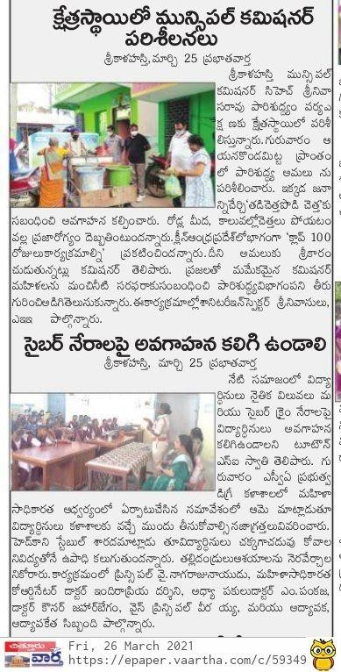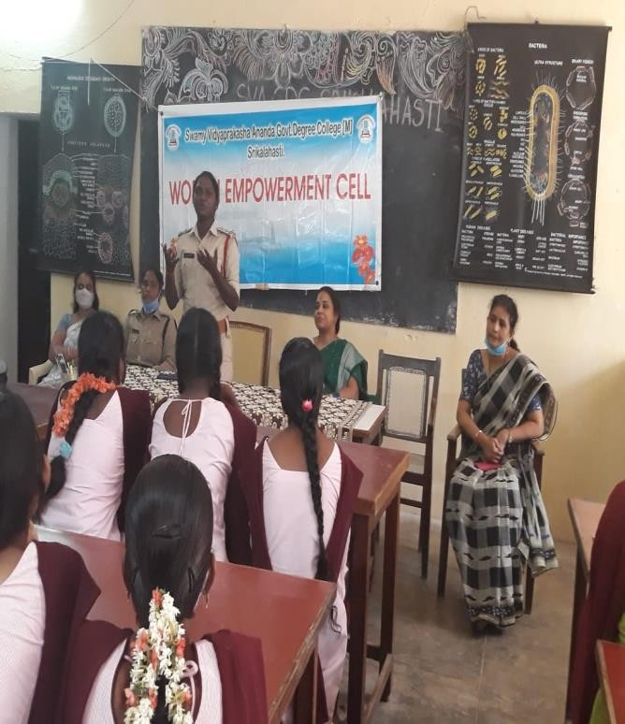



**Awareness on Importance of Girl Child on NATIONAL GIRL CHILD DAY CELEBRATION on 24.1.2022**

In SVA Government College (M), Srikalahasti, Women Empowerment Cell organized an awareness program on Importance of Girl Child on “**National Girl child Day Celebration**” for all girl students on 24.1.2022.

The objectives of the program is

* To promote girl child education
* To sensitize the society about the impact of gender discrimination on the overall development of the girls.

The college principal Dr.Y.Nagaraja Naidu, Vice-Principal Dr.N.Murali invited as chief guests. The Principal was given awareness about the education for sustainable development and Vice- PrincipalDr.N.Murali had given speech by girl child education and girl child rights. The WEC Convener SmtM.Thulasi said education for girls saves lives and builds stronger families, communities and economies. Dr.Kousar begum said about gender discrimination in India. All the teaching and non teaching of the collage and girl students participated this programme and completed successfully.

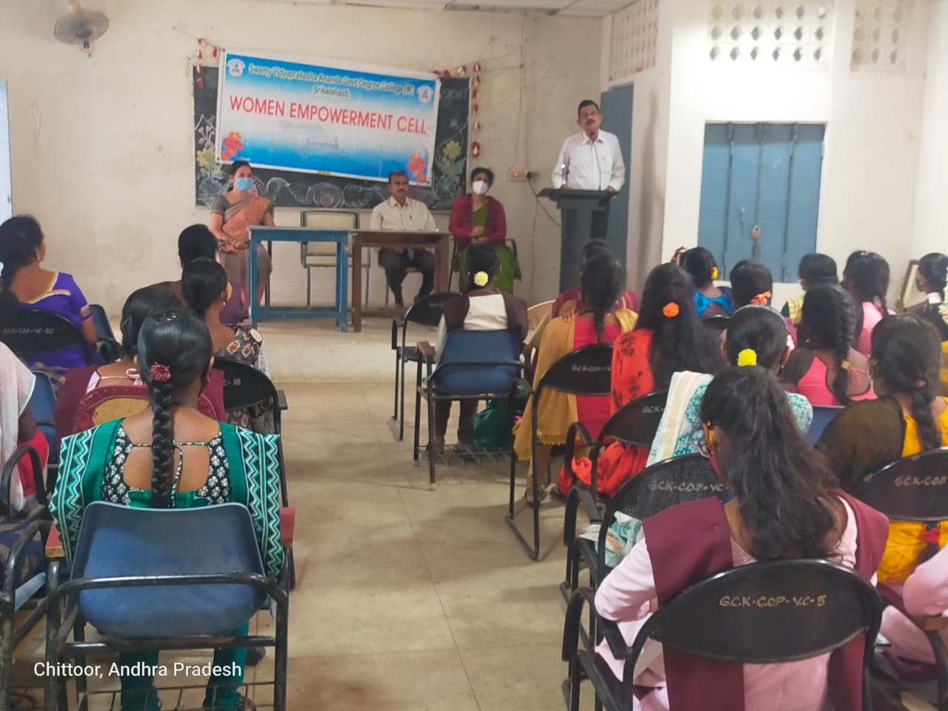**Principal Dr.Y.Nagaraja Naidu had given speech about Girl child Education**

**Vice-Principal Dr.N.Murali created awareness on girl child rights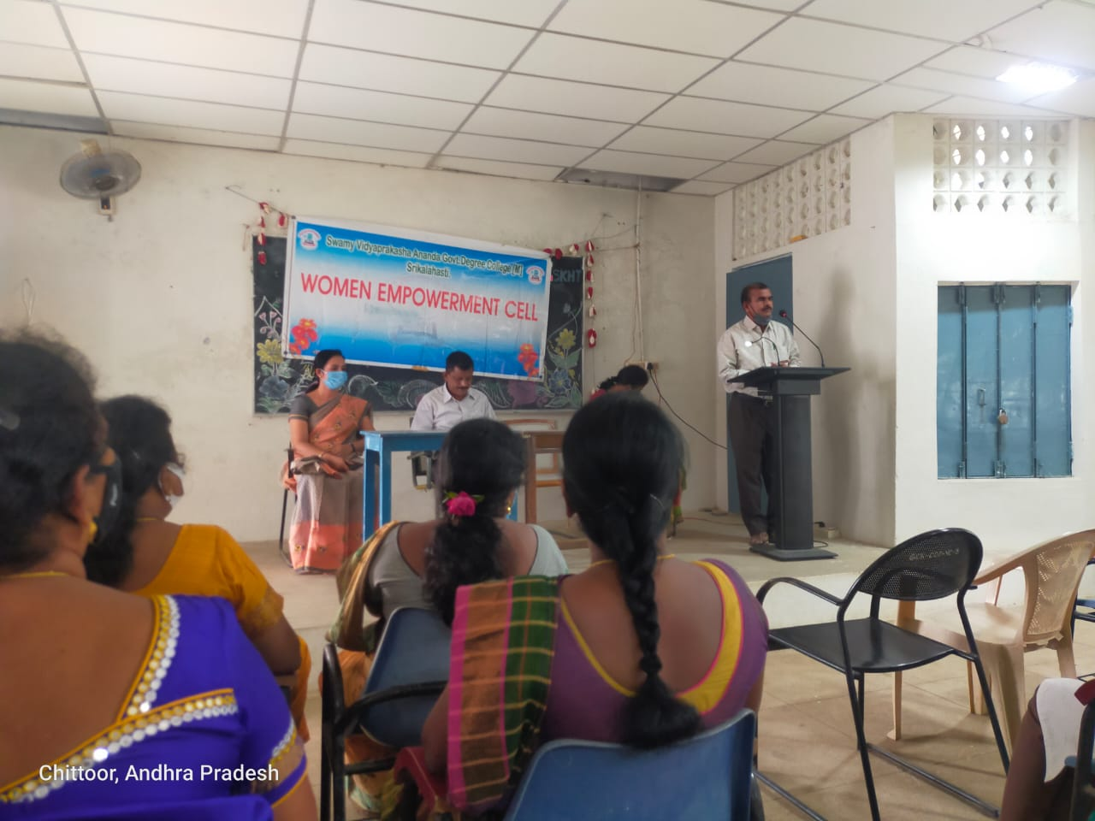Dr.Kousar Jaha Begum explained about Gender discrimination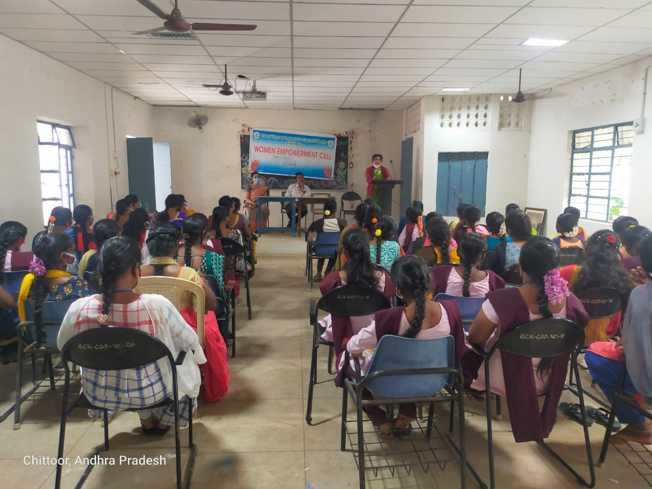Teaching, Non-teaching staffand students attended the program**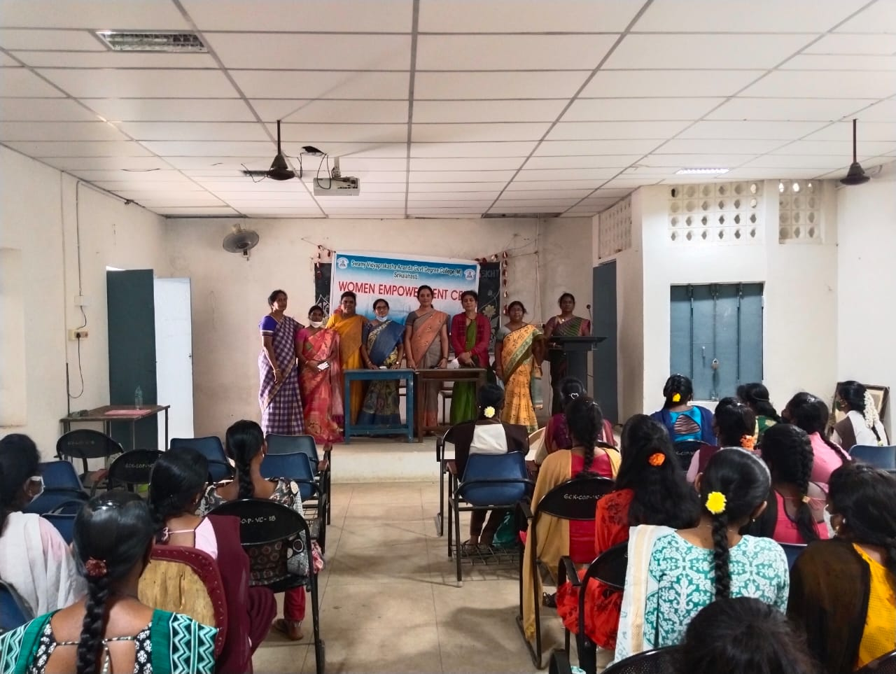

**Cancer Awareness Program on WORLD CANCER DAY on 4.2.2022**

In SVA Government College (M), Srikalahasti, Women Empowerment Cell organized an awareness program **“World Cancer Day”** on 4/2/2022, under the theme **‘close the care gap’**. The objective of the program is, to educate the girl students about the signs and symptoms of cancer to ensure early detection and treatment in the college community. WEC invited a Government Civil Surgeon specialist Dr.Y.Hima Devi MSDGO, Gynecologist as a chief guest. She said Cancer ranks as the second most common cause of death globally, with millions of new cases and fatalities annually. She included how to prevent it and the importance of early detection.

The college Vice-Principal Dr.N.Murali had given awareness of cancer and WEC convener Smt.M.Thulasi motivated the students to take a positive and proactive approach to fight against cancer. Girl students interact with the doctor to clarify their doubts. Finally felicitation ceremony was done to the chief guest Dr. Hima Devi by teaching and non-teaching staff. The program was successfully completed.

**Photographs**

**WEC convener Smt.M.Thulasi invited dignitaries on to the stage**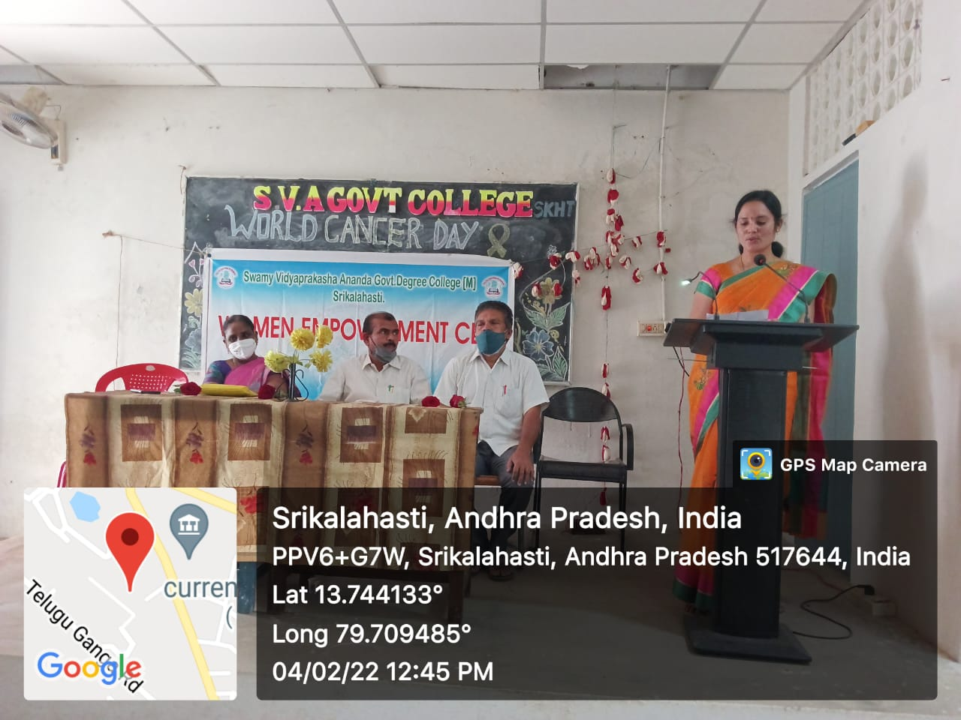

**Dr.Y.Hima Devi MSDGO, Gynecologist created awareness about cancer**

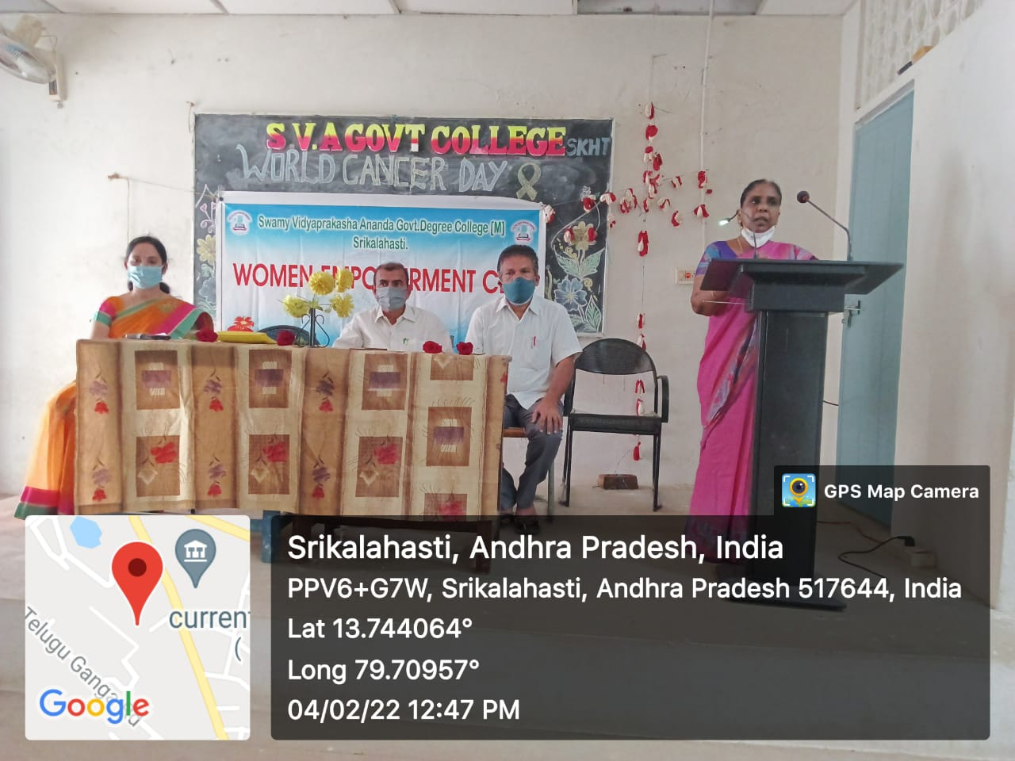

**Teaching and Non-teaching staff and Girl students participated in cancer awareness program**

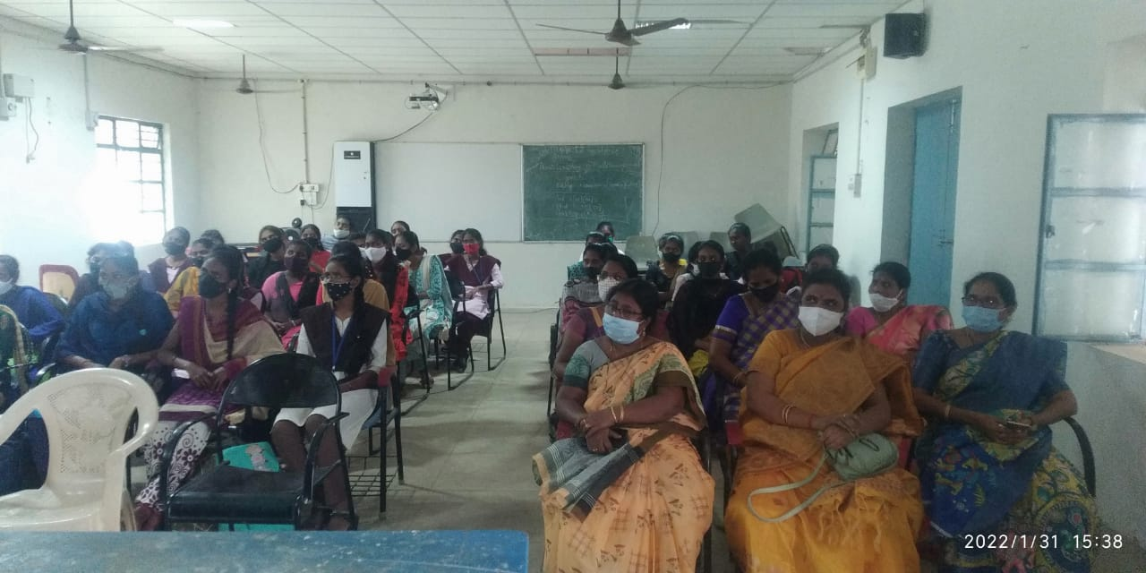

**Felicitation to the chief guest Dr.Y.Hima Devi MSDGO, Gynecologist**

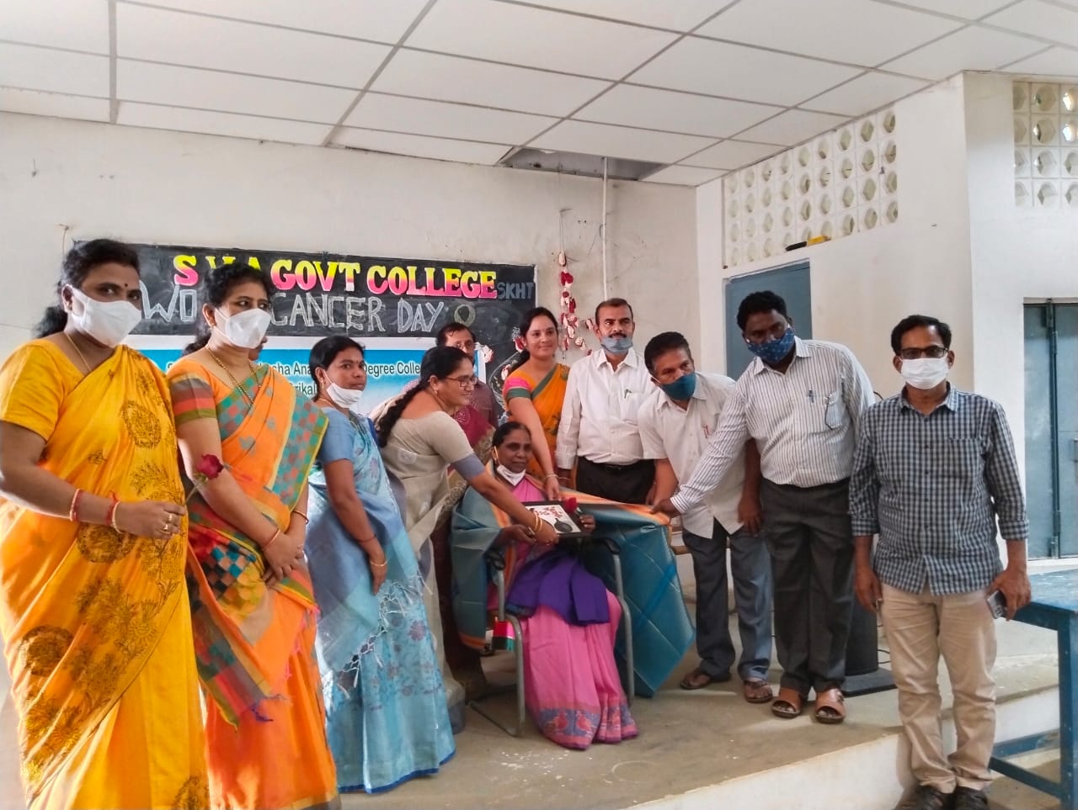

**Press clipping Sakshi paper : 05.02.2022**

